**HomeView**

**Network Diagram**

Uniting streaming services on one site

October 27, 2021

Unite

Christian Lam

Daniel Monge

Eric Truong (Team Leader)

Erina Lara

Michael Lamera

Table of Contents

**1. Network Diagram** **2**

**2. Technologies** **3**

2.1 Amazon Web Services Elastic Cloud Computing (EC2) 3

2.2 Amazon Web Services Relational Database Service 3

**3. Protocol** **4**

3.1 HTTPS 4

3.2 TCP/IP 4

3.3 SSL/TLS 4

**4. Flow** **4**

**5. References** **5**

# 

# 

# 

# 

# 

# 

# 

# 

# **1. Network Diagram**

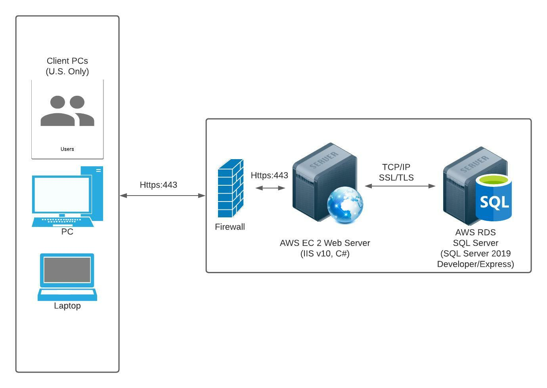

Note: [Link to edit diagram](https://lucid.app/lucidchart/715cf9b7-30a2-4435-bd01-101a82a2ede3/edit?view_items=wAuhDo3LAdlh&invitationId=inv_97b98f61-62a4-449b-a130-4766503ef5b3)

# **2. Technologies**

## 2.1 Amazon Web Services Elastic Cloud Computing (EC2)

* AWS EC2 is easy to navigate and set up compared to the others
* We can also purchase more storage space if needed instead of paying monthly subscriptions

## 2.2 Amazon Web Services Relational Database Service

* A service that sets up a relational database in the cloud
* Provides 20 GB of SSD database storage and 20 GB of backup storage for free per month

# **3. Protocol**

## 3.1 HTTPS

* With HTTPS, data is encrypted so even if personal information gets sniffed or intercepted, they will not be shown in plaintext. If we can’t find a secure free certificate, purchasing a SSL will be good for user security

## 3.2 TCP/IP

* Transmission Control Protocol allows application programs and computing devices to communicate with each other over a network
* Internet Protocol is the method of sending data from one device to another over the internet
* Together, the IP obtains and defines the IP address of the device the data must be sent to. TCP then transports the data through the network architecture to the intended destination

## 3.3 SSL/TLS

* Secure Sockets Layer, or Transport Layer Security, is a cryptographic protocol used to encrypt the communication between web applications and servers

# **4. Flow**

An interaction between the HomeView application and a client begins with a URL (HTTPS) request to the web application server. HomeView web servers are scoped such that they will only be serving clients inside the US. The request is first received by the firewall, which handles and filters appropriate requests such that only relevant and valid requests are passed. The rules used for firewall filtering are applied both ways (incoming and outgoing traffic). The firewall will handle requests only with HTTPS protocol, listening on port 443.

AWS EC2 Web Server listening on port 443 (HTTPS) will receive incoming traffic that comes from the firewall. The server hosting IIS returns the requested web content. Dynamic content requested by users will be handled by the web server’s IIS C# program. Content saved in the database server (Amazon’s RDS) will be transferred to the application according to a TCP/IP connection with SSL encryption. Updates, adds, and removal from the database server are made after the request is received. After the EC2 web server processes the request it returns web content to the firewall, which is then forwarded to the client’s browser using HTTPS.

# **5. References**

<https://www.mssqltips.com/sqlservertip/2182/network-communications-mechanisms-for-sql-server/>

<https://www.fortinet.com/resources/cyberglossary/tcp-ip>

<https://www.globalsign.com/en/ssl-information-center/what-is-ssl>

<https://www.internetsociety.org/deploy360/tls/basics/>